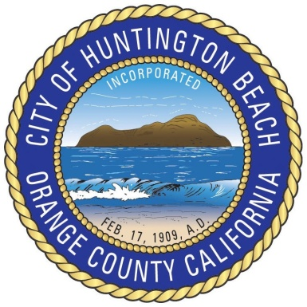

City of Huntington Beach

2000 Main Street ♦ Huntington Beach, CA 92648
(714) 536-5227 ♦ www.huntingtonbeachca.gov

Office of the City Clerk
Robin Estanislau, City Clerk

NOTICE OF CANCELLATION

CITY OF HUNTINGTON BEACH
REGULAR MEETING CITY COUNCIL/PUBLIC FINANCING AUTHORITY

Monday, March 5, 2018

Mayor Mike Posey
Mayor Pro Tem Erik Peterson
Councilmember Patrick Brenden
Councilmember Barbara Delgleize
Councilmember Jill Hardy
Councilmember William O’Connell
Councilmember Lyn Semeta

On December 18, 2017, the City Council announced that the Regular Meeting of the City Council/Public Financing Authority scheduled on Monday, March 5, 2018 at 4:00PM in the Council Chambers has been CANCELLED.

Dated: December 20, 2017

/s/ Robin Estanislau_____ /s/ Mike Posey ____
ATTEST: City Clerk Mayor

Sister Cities: Anjo, Japan ♦ Waitakere, New Zealand

